DIPC

IRISH PRELIMINARY COMPETITION
APPLICATION FORM
DUBLIN INTERNATIONAL PIANO COMPETITION 2022
Wednesday, 5 January 2022
TU Dublin Conservatoire, East Quad, Grangegorman, Dublin 7

IRISH PRELIMINARY COMPETITION FOR
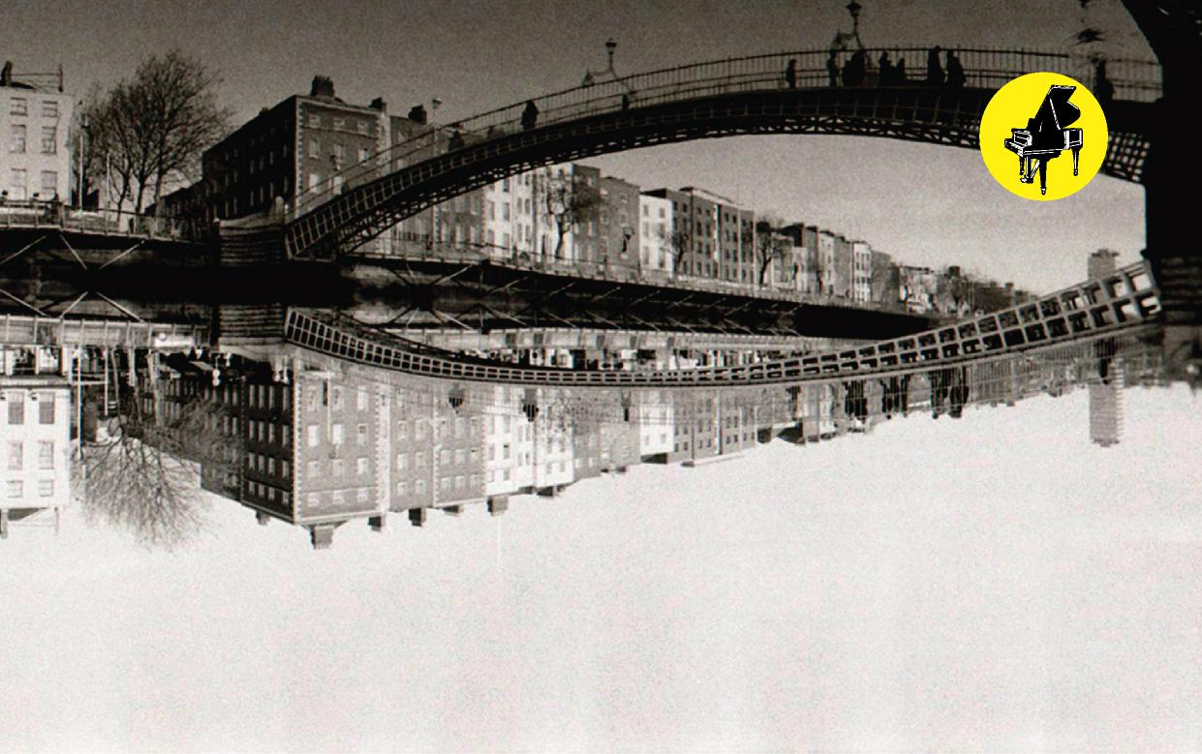
The 12th Dublin International Piano Competition
13-24 May 2022
DIPC
THE DUBLIN INTERNATIONAL PIANO COMPETITION
The Preliminary Irish Competition, to select five pianists to take part in the Dublin International Piano Competition in May 2022 will be held in TU Dublin Conservatoire, East Quad, Grangegorman, Dublin 7 on Wednesday, 5 January 2022.
RULES:
- The Competition is open to Irish pianists who were born before 13 May 2004 and after 13 May 1992.
(For purposes of this Competition the term Irish means those born in the 32 counties, those either of whose parents is Irish, or those who have resided in Ireland for most of their lives).
- Competitors should hold either one of the following performers’ diplomas:
LRIAM, LRAM or ARSM (or equivalent) or have won first prize in a Senior
competition at any of the following: Dublin Feis Ceoil, Cork or Sligo
Feiseanna or the Belfast Festival or be a student attending a 3rd level course in piano performance.
- Programmes must be played from memory.
- Order of performance will be decided by ballot.
- Competitors who are not available to perform when called upon to do so may be disqualified.
- Five competitors will be selected to enter the Dublin
International Piano Competition, but the Jury may alter this number as deemed fit.
- The decision of the Jury will be final and beyond appeal.

2

DIPC
ADJUDICATION
The Chairman of the Jury will be Jane Carty, and other members will include:
Mary Beattie — CIT Cork School of Music
Colma Brioscu — Royal Irish Academy of Music
Joe Csibi — General Manager, RTE Concert Orchestra
Reamonn Keary — Royal Irish Academy of Music
Mary Lennon — TU Dublin Conservatoire
Anthony Long — General Manager, RTE NSO
Orla McDonagh — Head, TU Dublin Conservatoire
Veronica McSwiney – Renowned Irish Pianist, FRIAM
Gabriela Mayer — CIT Cork School of Music
John O’Conor — Artistic Director, Dublin International Piano Competition
Pádhraic Ó Cuinneagáin — TU Dublin Conservatoire
Hugh Tinney — Royal Irish Academy of Music
ENGAGEMENTS & PRIZES
To help them prepare for the International Competition the five winners of this competition will participate in “The Maurice Foley Irish Competitors Training Programme”. Competing in an event such as the Dublin International Piano Competition requires not just piano-related skills. Therefore, the programme will include workshops and mentoring sessions from an experienced pianist and a music promoter to help them develop the mental strength and interactive skills on and off stage in order to help the competitors reach and sustain peak performance.
The Charles J. Brennan Prize of €1,500, presented in memory by his family, will be awarded to the highest placed Irish participant. This prize also awards recitals both in Ireland and abroad. Previous winners of the Brennan Prize are not eligible to win these prizes again.
Other prizes awarded to the winner of the Brennan Prize are the McCullough Bursary, in memory of the late Denis McCullough, founder of McCullough’s Music Shop, and his wife Agnes, and presented by his grandson Denis McCullough. The National Concert Hall prize of a performance at the National Concert Hall.
REPERTOIRE
Competitors must perform a 30 minute programme selected from the pieces to be presented in the Dublin International Piano Competition. Programmes chosen should demonstrate an understanding of programme building, an ability to play in a variety of musical styles and most importantly a depth of musicianship rather than mere technical brilliance.
The repertoire must have been written for solo piano and no alteration to the piano may take place. Time limits must be strictly adhered to and no piece may be played twice in the International Competition.
APPLICATIONS
The application form should be clearly completed and returned before 1 November, 2021 to
The Administrator, Dublin International Piano Competition
c/o AXA Insurance Building, Dublin Road, Bray, Co. Wicklow, A98 DT89, Ireland
Email: info@dipc.ie Phone 01 2721523
*Please note that elements of the 2022 Dublin International Piano Competition may
be subject to change, due to the ongoing uncertainties presented by Covid-19.

3

DIPC

THE FOLLOWING SHOULD BE INCLUDED WITH THE APPLICATION:

- Detailed CV to include copies of previous recital programmes,
prizes won and details of any public performances within the
past three years with programmes and reviews

- Copies of certificates or diplomas

- Entrance fee of €125.00.
The balance of €125.00 for the International Competition entrance
fee can be paid on selection into this Competition.

- Recital programmes for the Preliminary and for the Dublin International
Piano Competition

- Competitors should also complete the application form for the International
Competition.

4

DIPC
PROGRAMME
**IT IS IMPORTANT TO GIVE EXACT TIMINGS FOR EACH PIECE**
(Block letters or type)
PRELIMINARY COMPETITION: 30 minute recital
DUBLIN INTERNATIONAL PIANO COMPETITION:
1st Round: 30 minute recital
2nd Round: 40 minute recital
3rd Round: 50 (45) minute recital*
Finals:
(Name concertos in order of preference) 1
2
* In selecting the semi-final recital programme consideration in timing should be given to the compulsory 5 minute set piece by an Irish composer

5

DIPC
APPLICATION FORM
FAMILY NAME
FORENAMES
DATE OF BIRTH PLACE OF BIRTH
LENGTH OF TIME SPENT IN IRELAND
PERMANENT ADDRESS
TELEPHONE
E-MAIL ADDRESS
PRESENT ADDRESS (IF DIFFERENT)
TELEPHONE
MUSICAL EDUCATION:
DATES
PLACES
TEACHERS
DECLARATION:
I have read the rules of the Competition and if accepted as a competitor agree to conform to them
Signature: Date:
Competitors may give further information in support of their application on a
separate sheet of paper which should be attached to this form
6

